GOVERNMENT DEGREE COLLEGE, TADIPATRI,
ANANTAPUR DISTRICT, ANDHRA PRADESH

ANNUAL QUALITY ASSURANCE REPORT (AQAR) 2019-20

Submitted to
NATIONAL ASSESMENT AND ACCREDITATION COUNCIL (NAAC) BANGALORE
The Annual Quality Assurance Report (AQAR) of the IQAC

All NAAC accredited institutions will submit an annual self-reviewed progress report to NAAC, through its IQAC. The report is to detail the tangible results achieved in key areas, specifically identified by the institutional IQAC at the beginning of the academic year. The AQAR will detail the results of the perspective plan worked out by the IQAC. (Note: The AQAR period would be the Academic Year. For example, July 1, 2012 to June 30, 2013)

Part – A

1. Details of the Institution
1.1 Name of the Institution GOVERNMENT DEGREE COLLEGE, Tadipatri
1.2 Address Line 1 Near Auto Nagar
Address Line 2 Tadipatri
City/Town ANANTAPUR (Dist.,)
State ANDHRA PRADESH
Pin Code 515411
Institution e-mail address jkc.tadipatri@gmail.com
Contact Nos. 08554-222325 & 9290500488
Head of the Institution: Dr. B.Vijayalakshmi
Tel. No. with STD Code: 08554-222325
9290500488
Mobile:
Name of the IQAC Co-ordinator: Sri A.Showkath ali
9985229288
Mobile:
iqac.tadipatri@gmail.com
IQAC e-mail address:

APCOGN13270
1.3 NAAC Track ID (For ex. MHCOGN 18879)

NAAC/WH/Cert-A&A/2007/197 dt 24-4-2007
1.4 NAAC Executive Committee No. & Date:
(For Example EC/32/A&A/143 dated 3-5-2004.
This EC no. is available in the right corner- bottom of your institution’s Accreditation Certificate)

www.gdctadipatri.ac.in
1.5 Website address:

http://www.gdctadipatri.ac.in/facilities.php?id=6

Web-link of the AQAR:
For ex. http://www.ladykeanecollege.edu.in/AQAR2012-13.doc 1.6 Accreditation Details
Sl. No. | Cycle | Grade | CGPA | Year of  Accreditatio n | Validity Period
1 | 1st Cycle | B⁺ | 76.00 | 2007 | 5Years
2 | 2nd Cycle
3 | 3rd Cycle
4 | 4th Cycle

18.06.2011

1.7 Date of Establishment of IQAC: DD/MM/YYYY

2019-20
1.8 AQAR for the year (for example 2010-11)

1.9 Details of the previous year’s AQAR submitted to NAAC after the latest Assessment and Accreditation by NAAC ((for example AQAR 2010-11submitted to NAAC on 12-10-2011)
i. AQAR _2012-13_submitted to NAAC on 26/12/2018 (DD/MM/YYYY) ii. AQAR _2013-14_submitted to NAAC on 26/12/2018 (DD/MM/YYYY)
iii.AQAR _2014-15_submitted to NAAC on 26/12/2018 (DD/MM/YYYY)
iv. AQAR _2015-16_submitted to NAAC on 26/12/2018 (DD/MM/YYYY) v. AQAR _2016-17_submitted to NAAC on 26/12/2018 (DD/MM/YYYY)
vi. AQAR _2017-18_submitted to NAAC on 26/ 12 /2018 (DD/MM/YYYY)
vii. AQAR _ 2018-19submitted to NAAC on / /2022 (DD/MM/YYYY)

1.10 Institutional Status
University State  Central Deemed Private

Affiliated College Yes  No
Constituent College |  | Yes No
Autonomous college of UGC Yes No
Regulatory Agency approved Institution Yes No
(eg. AICTE, BCI, MCI, PCI, NCI)
Type of Institution Co-education  Men Women

Urban Rural  Tribal

Financial Status Grant-in-aid UGC 2(f)  UGC 12B 

Grant-in-aid + Self Financing Totally Self-financing

1.11 Type of Faculty/Programme

Arts  Science  Commerce  Law PEI (Phys Edu)

TEI (Edu) Engineering Health Science Management

Others (Specify)
SRI KRISHNADEVARAYA UNIVERSITY, ANANTAPUR
1.12 Name of the Affiliating University (for the Colleges)

1.13 Special status conferred by Central/ State Government-- UGC/CSIR/DST/DBT/ICMR etc

Autonomy by State/Central Govt. / University

University with Potential for Excellence UGC-CPE

UGC-CE
DST Star Scheme

01 | DST-  FIST
UGC-Special Assistance Programme

 | Any other (Specify | )
UGC-Innovative PG programmes

UGC-COP Programmes
- IQAC Composition and Activities
4
1
  - No. of Teachers
  - No. of Administrative/Technical staff
  - No. of students ⁶
  - No. of Management representatives 1
  - No. of Alumni 1
- 6 No. of any other stakeholder and community representatives ⁴
  - No. of Employers/ Industrialists 3
  - No. of other External Experts 2
  - Total No. of members ₂₂
2.10 No. of IQAC meetings held |  | 2
3
  - No. of meetings with various stakeholders: No. Faculty ¹

0
1 | Alumni | 1
Non-Teaching Staff Students Others

  - Has IQAC received any funding from UGC during the year? Yes No
If yes, mention the amount
2.13Seminars and Conferences (only quality related)
    - No. of Seminars/Conferences/ Workshops/Symposia organized by the IQAC

Total Nos. 2 International National State Institution Level

• | Faculty Development Programme on “Soft skills for Teaching” held on 13th August 2017.
• | Faculty Development Programme on “Professional ethics for Teaching” held on 3rd March 2018.
    - Themes

2.14Significant Activities and contributions made by IQAC
        - Compilation of APIs ( Both Hard & Soft Copies)
        - Preparation of proposals for various UGC schemes
        - Promotion of proposals for Seminars /Projects

2.15Plan of Action by IQAC/Outcome
The plan of action chalked out by the IQAC in the beginning of the year towards quality enhancement and the outcome achieved by the end of the year
Plan of Action | Achievements
I. Proposed to increase Community services. | - Volunteer Blood Donation Awareness  Camps  - Special Camps on Clean and Green by  NSS Units in Rural Areas  - Red Ribbon Club Activities to Create  Awareness on AIDS  - Women Empowerment Cell activities  - Blood group testing for students
II. Proposed to conduct cultural festival to bring out innate potentialities of students. | A) Cultural Activities on the eve of Fresher day celebrations and Valedictory function
III. Proposed to organize medical health camps. | A) Medical Health Camps by NSS Units in College
IV. Proposed to arrange study tours and educational trips to the students of different subjects. | A) Field Trips by Departments of Botany and History.
V. Proposed to arrange parents meet during the commencement and closure of every academic year. | A) Parents’ meet held at the commencement and Closure of academic year
VI. Proposed to add educational CDs in various subjects to enrich ICT learning resources. | ICT teaching methodology through CDs and  PPTs was adopted
VII. Proposed to organize the remedial classes for slow learners in effective manner. | Remedial Coaching is arranged in all Subjects for Slow Learners.
VIII. Proposed to celebrate all days of National and International Importance | Celebrated  1) World Blood Donor Day

- UNO Day
- Independence Day & National Education Day
- Womens’ Equality Day
- Teachers’ Day
- National Literacy Day
- Hindi Divas
- NSS Day
- Gandhi Jayanthi and Lal Bahadur Sastri
Jayanthi
- AIDS Day
- Human Rights Day
- National Consumers Day
- National Voters Day
- Republic Day
- National Science Day
- International Women’s Day
- Tanguturi Prakasam Birthday
- World students day
- Ramanujan Birthday:Mathematics day
- Jaashuva Vardanti
IX. Proposed to organize short term coaching classes towards career development to increase competence of the students to attempt all competitive examinations and to face the placement officers. | Conducted coaching classes for Competitive exams
X. Proposed to increase the number of teams for playing Cricket, Volley ball, Hockey, Foot ball, Chess, TT and sports. | Number of Students for Sports and Games are increased
XI Proposed to conduct group discussions, quizzes, essay writing and debates on various subjects involving large number of students. | Conducted group discussions, quizzes, essay writing and debates on various subjects involving large number of students.  Conducted Indian Geography District Quiz by History Department
XIII. Proposed to make use of MANA TV programs more effectively | Students regularly attended MANA TV programmes as per the schedule
XIII. Proposed to organize coaching classes for the students to appear for PG entrances during the academic year | Coaching is given for PGCET exams
XIV. Proposed to enlighten women students on health and hygiene | Women Empowerment Cell conducted  programmes on health and hygiene
XV . Proposed to invite experts from various fields and organize guest lecturers to the students and staff to enhance various skills and knowledge. | Invited Lectures are arranged in various subjects.
XVI. Proposed to motivate more number of students in the preparation of student projects | Student Study Projects were given in many subjects
XVII. Proposed to organize blood camps, and awareness about AIDS, HIV, etc., | Organized camps on awareness about AIDS,  HIV, etc.,
* Attach the Academic Calendar of the year as Annexure.

2.15 Whether the AQAR was placed in statutory body Yes  No Management Syndicate Any other body

Provide the details of the action taken
To improve the above said events for the next academic year with much more participation of the students. AQAR was placed before the Staff council; after active discussions, incorporated valid suggestions. Staff council has approved the final report and gave sanction to forward the AQAR to NAAC

Part-B

Criterion – I

- Curricular Aspects
  - Details about Academic Programmes
Level of the Programme | Number of existing  Programmes | Number of programmes  added during the year | Number of self-financing programmes | Number of value added / Career  Oriented programmes
PhD
PG
UG | 04 |  | 02
PG Diploma
Advanced Diploma
Diploma
Certificate
Others
Total | 04 |  | 02

Interdisciplinary
Innovative

  - (i) Flexibility of the Curriculum: Core (ii) Pattern of programmes:
Pattern | Number of programmes
Semester | 6 semesters,UG programmes
Trimester
Annual |  6 (III) UG programmes

  - Feedback from stakeholders*

 | Students | 

Alumni Parents Employers (On all aspects)
Mode of feedback : Online Manual  Co-operating schools (for PEI) *Please provide an analysis of the feedback in the Annexure
  - Whether there is any revision/update of regulation or syllabi, if yes, mention their salient aspects.
No

  - Any new Department/Centre introduced during the year. If yes, give details.
1.UGC Sponsored Add on Course on Communication skills and Spoken English by English
Department
2.Cetificate course introduced by the Department of Commerce entitled Tally Package by
Commerce Department

Criterion – II 2. Teaching, Learning and Evaluation
Total | Asst. Professors | Associate Professors | Professors | Others
12 | 12
2.1 Total No. of
permanent faculty

00
2.2 No. of permanent faculty with Ph.D.
Asst.  Professors |  | Associate Professors |  | Professors |  | Others |  | Total
R | V | R | V | R | V | R | V | R | V
12 | 07 |  |  |  |  |  |  |  | 07
2.3 No. of Faculty Positions
Recruited (R) and Vacant (V) during the year

2.4 No. of Guest and Visiting faculty and Temporary faculty
02 |  |  |  | 02
2.5 Faculty participation in conferences and symposia:

No. of Faculty | International level | National level | State level
Attended |  | 10
Presented |  | 06
Resource Persons

2.6 Innovative processes adopted by the institution in Teaching and Learning:

Using PPTs, CDs & Internet

226
2.7 Total No. of actual teaching days during this academic year
NA
2.8 Examination/ Evaluation Reforms initiated by the Institution (for example: Open Book Examination, Bar Coding,
Double Valuation, Photocopy, Online Multiple Choice Questions)

02 BOS
2.9 No. of faculty members involved in curriculum
Restructuring / revision/ syllabus development
as member of Board of Study/Faculty/Curriculum Development workshop

80
2.10 Average percentage of attendance of students

2.11 Course/Programme wise distribution of pass percentage :

Title of the  Programme | Total no. of students appeared |  |  | Division
 |  | Distinction  % | I % | II % | III % | Pass %
B.Sc. | 30 | 2 | 3 | 5 | 6 | 53.85%
B.A. | 17 |  | 3 | 4 | 10 | 83%
B.Com. | 40 | 1 | 3 | 6 | 9 | 47.66%
2.12 How does IQAC Contribute/Monitor/Evaluate the Teaching & Learning processes:
By Interaction with the Faculty, Feed Back from the Students and Parents, Result Analysis,
Monitoring regular tests, assignments, Quiz, group discussions etc
2.13 Initiatives undertaken towards faculty development
Faculty / Staff Development Programmes | Number of faculty benefitted
Refresher courses | 01
UGC – Faculty Improvement Programme
HRD programmes
Orientation programmes
Faculty exchange programme
Staff training conducted by the university
Staff training conducted by other institutions | 01
Summer / Winter schools, Workshops, etc.
Others: Training in Human Values and professional ethics | 01
2.14 Details of Administrative and Technical staff
Category | Number of  Permanent  Employees | Number of  Vacant  Positions | Number of permanent  positions filled during the Year | Number of  positions filled temporarily
Administrative Staff | 05 | 07
Technical Staff

Criterion – III
- Research, Consultancy and Extension
  - Initiatives of the IQAC in Sensitizing/Promoting Research Climate in the institution
Giving information and motivating the faculty to apply and to carry on Ph.D,
Informing the details of various seminars and workshops held at different places
  - Details regarding major projects
 | Completed | Ongoing | Sanctioned | Submitted
Number
Outlay in Rs. Lakhs
  - Details regarding minor projects
 | Completed | Ongoing | Sanctioned | Submitted
Number
Outlay in Rs. Lakhs
  - Details on research publications
 | International | National | Others
Peer Review Journals
Non-Peer Review Journals
e-Journals
Conference proceedings |  | 01

  - Details on Impact factor of publications:
Range Average h-index Nos. in SCOPUS

  - Research funds sanctioned and received from various funding agencies, industry and other organisations
Nature of the Project | Duration Year | Name of the funding Agency | Total grant sanctioned | Received
Major projects
Minor Projects
Interdisciplinary Projects
Industry sponsored
Projects
sponsored by the
University/
College
Students research projects (other than compulsory by the University) | 2018-19 | Alumni Association and staff | 2,000 | 2,000
Any
other(Specify)
Total |  |  | 2,000 | 2,000

  - No. of books published i) With ISBN No. Chapters in Edited Books

ii) Without ISBN No.
  - No. of University Departments receiving funds from
UGC-SAP CAS DST-FIST
DPE DBT Scheme/funds
  - For colleges Autonomy CPE DBT Star Scheme

INSPIRE CE Any Other (specify)
  - Revenue generated through consultancy
  - No. of conferences organized by the Institution
Level | International | National | State | University |  |  | College
Number |  |  |  |  |  |  | 3
Sponsoring agencies |  |  |  |  |  |  | Staff  Contribution
3.12 No. of faculty served as experts, chairpersons or resource persons |  |  |  |  | 2
  - No. of collaborations International National Any other
043
  - No. of linkages created during this year
  - Total budget for research for current year in lakhs :
From Funding agency From Management of University/College
Total
  - No. of patents received this year
Type of Patent |  | Number
National | Applied
 | Granted
International | Applied
 | Granted
Commercialised | Applied
 | Granted

  - No. of research awards/ recognitions received by faculty and research fellows of the institute in the year

Total | International | National | State | University | Dist | College
  - No. of faculty from the Institution who are Ph. D. Guides

and students registered under them

  - No. of Ph.D. awarded by faculty from the Institution

  - No. of Research scholars receiving the Fellowships (Newly enrolled + existing ones)
 | SRF |  | Project Fellows Any other
JRF
  - No. of students Participated in NSS events:
University level 60 State level
National level International level
  - No. of students participated in NCC events:
University level State level
National level International level

  - No. of Awards won in NSS:
University level State level National level International level
  - No. of Awards won in NCC:
University level State level
National level International level
  - No. of Extension activities organized
10
University forum College forum
10
NCC NSS 6 Any other
  - Major Activities during the year in the sphere of extension activities and Institutional Social Responsibility
Volunteer Blood Donation Awareness, AIDS Awareness Programmes, Women Empowerment Cell activities

Criterion – IV
- Infrastructure and Learning Resources
  - Details of increase in infrastructure facilities:
Facilities | Existing | Newly  created | Source of Fund | Total
Campus area | 10.0Acres |  |  | 10. 0Acres
Class rooms | 11 |  |  | 11
Laboratories | 06 |  |  | 06
Seminar Halls | 01 |  |  | 01
No. of important equipments purchased
(≥ 1-0 lakh) during the current year.
Value of the equipment purchased during the year (Rs. in Lakhs) | 30 | 01 Computer | UGC | 31
Others | 01 | 01 | OOE | 02

  - Computerization of administration and library

No
  - Library services:
 | Existing |  | Newly added |  | Total
 | No. | Value | No. | Value | No. | Value
Text Books | 10453 | 1200000  /- | - | - | 10453 | 1200000/  -
Reference Books | 1050 | 98690/- | - | - | 1050 | 98690/-
e-Books | - | - | - | - | - | -
Journals | 5 | 8000/- | - | - | 5 | 8000/-
e-Journals | - | - | - | - | - | -
Digital Database | - | - | - | - | - | -
CD & Video | 50 | 2500/- |  |  | 50 | 2500/-
Others (specify) | - | - | - | - | - | -

  - Technology up gradation (overall)
 | Total Computers | Computer Labs | Internet | Browsing Centres | Computer Centres | Office | Departments | Others
Existing | 24 | 2 | Available  to all Depts |  |  | 3  Computers in use | 3 Computers in use
Added
Total | 24 | 2 | Available  to all Depts |  |  | 3  Computers in use | 3 Computers in use

  - Computer, Internet access, training to teachers and students and any other programme for technology upgradation (Networking, e-Governance etc.)

Trainings to teachers in soft skills provided by Computer Department

  - Amount spent on maintenance in lakhs :
25,000/-
    - ICT

2,00,000 /-
    - Campus Infrastructure and facilities

_
    - Equipments

1,00,000/-
    - Others

3,25,000/- Total
Total

Criterion – V

5. Student Support and Progression
5.1• Contribution of IQAC in enhancing Created awareness on applying for scholarships, Bus Pass, Internet browsing.awareness about Student Support Services
- Displays about anti-ragging cell, medical emergency facilities and details of student welfare officers were made.
- Separate notice boards were used to display day to day information related to curriculum, scholarship, examinations, placement, cultural, social activities and all other programmes.
- Student is allowed to express their views and suggestions regarding support services to any member of the IQAC
- The IQAC has taken initiative by providing students support services like Guidance and Counselling, Training and Placement, Grievance Redressal Cell, Anti-ragging, remedial classes etc. on a day to day basis.
GOVERNMENT DEGREE COLLEGE, TADIPATRI-515411, ANANTAPUR DISTRICT Page 18
- Parents/guardians are informed about performances, attendance and examinations. Repeated messages (telephone and emails) are sent to the students about the day to day activities.
5.2 Efforts made by the institution for tracking the progression
• | Student Progression registers are maintained department wise and Central register is also maintained
• | Departmental programmes and inter disciplinary programmes are arranged which is followed by feedback to assess its effect on the students.
• | Academic advisors work together with the counselling services to assess the overall development of the students
5.3 (a) Total Number of students
UG | PG | Ph. D. | Others
218 | 0 | 0 | 0
- No. of students outside the state
- No. of international students
No | %
178 | 81.36
No | %
40 | 18.63
Men Women

Women

 |  | Last Year 2018-19 |  |  |  |  |  | This Year 2019-20
Gene ral | SC | ST | OBC | Physically  Challenged  &  Others | Total | Gen  eral | SC | ST | OBC | Physically Challenged | Tota l
14 | 91 | 5 | 137 | 0 | 224 | 32 | 67 | 4 | 115 | 0 | 218
Demand ratio 1:15 Dropout 3.10%
5.4 Details of student support mechanism for coaching for competitive examinations (If any)
Career Development and Orientation Programs are being initiated for the students and were also informed regularly about the various competitive examinations

provided.

Library disseminate and information about announcement regarding competitive exams and has separate section of books meant for preparation.
5 programmes have been organized in this academic year and more than 50 students participated in each and every programme.

No. of students beneficiaries -- 155
  - No. of students qualified in these examinations
NET SET/SLET GATE CAT
IAS/IPS etc State PSC UPSC Others
  - Details of student counselling and career guidance
• | In the month of July 2014 the First year students residing in the SC & ST Hostel, Tadipatri were given guidance and counselling sessions about adjustment and personal issues.
• | Awareness program followed by counselling sessions were given to students on Career Planning and success
• | Counselling session on developing right attitude and overcoming negative thought process was organised for all students

No. of students benefitted: 49
  - Details of campus placement
 | On campus |  | Off Campus
Number of  Organizations  Visited | Number of  Students  Participated | Number of Students Placed | Number of Students Placed
0 | 0 | 0 | 10

  - Details of gender sensitization programmes
• | International Women’s Day celebrated
• | Antiragging Awareness Programme
• | Women Health and hygiene Awareness Programme

  - Students Activities
    - No. of students participated in Sports, Games and other events
State/ University level 20 National level International level No. of students participated in cultural events

State/ University level National level International level

    - No. of medals /awards won by students in Sports, Games and other events
3 | National level International level
Sports : State/ University level

Cultural: State/ University level National level International level

  - Scholarships and Financial Support
 | Number of students | Amount
Financial support from institution
Financial support from government | 183 | 19,17,500/-
Financial support from other sources
Number of students who received
International/ National recognitions
  - Student organised / initiatives
Fairs : State/ University level National level International level
Exhibition: State/ University level National level International level

18
  - No. of social initiatives undertaken by the students:

  - Major grievances of students (if any) redressed:
- Need more drinking water facility
- Lot of Monkey menace

Criterion – VI

6. Governance, Leadership and Management
6.1 State the Vision and Mission of the institution

Vision

To impart higher education with knowledge amalgamated with ethnical norms and values which involves academic excellence, spiritual growth, social commitment and value based leadership.

Mission

To entrust its products with the responsibility of involving themselves in “Make in

India” and mould the Students by tapping their innate potentialities to establish themselves as global citizens with utmost competence, conscience, confident, compassionate and commitment skills. Special concern is shown towards the socially

and economically marginalized rural students.

6.2 Does the Institution has a management Information System

• | Administrative procedures including finance: includes student and staff profiles, fee management, accounting, issue of certificates (bonafide, transfer certificate, grade sheet, degree certificate, etc.), etc.
• | Student records: apart from personal profiles, this includes student admission records, marks& grades, student progression data, progress reports, Fees reimburement information, etc.
• | Evaluation & Examination procedures: the entire gamut of activities from registration through results, including attendance and other data are maintained with appropriate access levels to students, faculty, administrative personnel, parents, and other stakeholders.
-

6.3 Quality improvement strategies adopted by the institution for each of the following: 6.3.1 Curriculum Development

The college offered three courses which include B.Sc, B.Com and B.A. The Institution is affiliated to Sri Krishnadevaraya University, Anantapur and hence it adopts the Curriculum developed by the University. However, All the courses provide in depth knowledge of the various aspects of their respective courses and the students get exposed to the contents beyond the syllabus through the methodologies like assignments, min iprojects, seminars, workshops, etc. Additional inputs are given along with the curricular

aspects.

6.3.2 Teaching and Learning

• | These programmes were organised to increase the awareness level of the staff members not just in academic matters but also in general topics and life skills.  ICT based teaching and techniques are adopted
• | Annul Curricular Plans and Lesson plans were prepared by the faculty members and the same were verified by the Vice Principal.
• | Course Materials were prepared by the faculty members and the same were thoroughly verified by the Vice Principal.
• | Slips Tests, Unit Tests, Quizzes etc. were conducted by the Faculty Members to ensure that the students understand the concept in the curriculum in an efficient and effective manner.
• | Feedbacks were taken by the respective Heads of Departments from the students with the regard to the performance of the Faculty members and the Faculty were counselled, if necessary
6.3.3 Examination and Evaluation
• | Since the institution is affiliated to Sri Krishnadevara ya University, Anantapur, the Year End Exams are conducted and the same are evaluated by the above cited University. The Marks Memos are also awarded by the University.
• | Regular periodical tests, Assignments and evaluation is done by all concerned faculty members

6.3.4 Research and Development
• | The institute encourages teachers and students to participate in  International/National seminars/workshops/conferences
• | Invited talks of experts from other institutions are arranged.
• | Teachers and Students are encouraged to publish papers in journals and conferences/ seminar proceedings.

6.3.5 Library, ICT and physical infrastructure / instrumentation
Subscribed Latest journals and magazines, Educational CDs & DVDs, Computer labs

The faculty can access on-line teaching and learning resources and other knowledge and information database/packages provided to the staff and students for quality teaching, learning and research through internet facilities.
Teachers have access to internet, can download teaching materials and resources and take copies through the reprographic centre, free of cost.
The college provides the basic necessities for research also in terms of lab facilities, instruments and open access library facilities which provides good atmosphere for effective teaching and research.

6.3.6 Human Resource Management
- Quality improvement strategies adopted by the institution for Human Resource Management include the following:

- Academic Audit was conducted with regard to the academic matters every
year
- The Orientation Programme was conducted for the staff in the College.
They were sent to various training and development progammes in and outside the campus.
- The Grievance Cell was operated actively to resolve the issues with regard to Human Resource Management

6.3.7 Faculty and Staff recruitment

- All the appointments were made as per the Government norms and UGC
guidelines.
- Roster system is followed while filling up the vacancies as per Andhra Pradesh Government norms.
-

6.3.8 Industry Interaction / Collaboration
Some departments have interaction with the local industries
Our institution has established linkages with some organizations for pursuing research and carrying out extension programmes. These linkages programmes are

beneficial to the faculty members for developing their expertise and provide a platform for hands on training.

6.3.9 Admission of Students

• | The institution adopts the norms prescribed by the bodies such as APCCE, Sri Krishnadevaraya University, UGC etc. which improves the quality in admission of students.
• | While admitting the students into the programmes proper measures are adopted to ensure the quality in admission of students.
• | Admissions are made as per the Merit and reservation

Teaching | Yes
Non  teaching | Yes
Students | Scholarships, Bus Pass, Coaching for competitive exams
6.4 Welfare schemes for

- The institution maintains a Health centre by visiting Doctor and a well-trained Nurse for the benefit of staff and students.
- Appropriate arrangements are made to take the staff and students to the nearby hospital whenever advanced medical care is needed.

  - Total corpus fund generated

  - Whether annual financial audit has been done Yes  No
  - Whether Academic and Administrative Audit (AAA) have been done?
Audit Type | External |  | Internal
 | Yes/No | Agency | Yes/No | Authority
Academic | Yes | CCE | No
Administrative | No |  | No

  - Does the University/ Autonomous College declare results within 30 days?
For UG Programmes Yes  No

For PG Programmes Yes No
  - What efforts are made by the University/ Autonomous College for Examination Reforms?
 | The following efforts are made by the University/Autonomous Institution for Examination Reforms:
• | The University appoints the observers to supervise the annual examinations and suggest the reforms thereby.
• | The University conducts meetings with the BoS staff of the affiliated colleges to discuss about the reforms.

  - What efforts are made by the University to promote autonomy in the affiliated/constituent colleges?
• | Participation of the college teachers in the events organized by the university
• | Inviting experts from the University for College programs.

  - Activities and support from the Alumni Association
• | Feedback for the Alumni is being continuously received for academic development and career opportunities for students
• | Enrolment campaign for alumni association

  - Activities and support from the Parent – Teacher Association
• | Cooperation in maintaining Discipline in the college, smooth functioning of College, enhancing the image of the college
• | It conducts frequent meetings

  - Development programmes for support staff
Support Staff Development Programmes (lectures/training programmes) are conducted regularly by the institution as a whole and by the individual departments. The areas covered by the training programmes include the following:
- Computer training
- Internet
- Audio-visual aids
  - Initiatives taken by the institution to make the campus eco-friendly
• | Ban on Using Plastic in the Campus
• | Waste bins are placed throughout the campus
• | Awareness programs were conducted for the students.
• | Signboards bearing the messages of the importance of keeping the campus ecofriendly are placed inside the campus.

Criterion – VII 7. Innovations and Best Practices
7.1 Innovations introduced during this academic year which have created a positive impact on the functioning of the institution. Give details.
• | Various Prizes are given away to the meritorious students in sports and academics by staff contribution.
• | Student Council/ Faculty Forum organizes inter departmental discussions on various intellectual, technical, ethical and basic issues.
• | Computer Science department conducts training programs for teaching and non-teaching staff to upgrade their computer related skills.
• | Organization of awareness program on Volunteer Blood Donation Camps by  Department of Political Science
• | Providing basic amenities and funds to the Sri Krishna Vruddashram Persons at Tadipatri, by Political Science and Mathematics Departments
• | Celebrating Sir Srinivasan Ramanujan’s Birthday involving mathematics’ students in various activities like Elocution, Quiz, Seminar, etc., every year on 22nd of December, by Department of Mathematics
• | CPM – Capacity Practice Motivation: Every teacher should evaluate the learner before he/she starts the implementation of teaching in the class room by following afore said strategy.

7.2 Provide the Action Taken Report (ATR) based on the plan of action decided upon at the beginning of the year

Action Taken Report (ATR)
- Awareness program on Volunteer Blood Donation Camps
- Special Camps on Clean and Green by NSS Units in Rural Areas
- Red Ribbon Club Activities to Create Awareness on AIDS
- Women Empowerment Cell activities
- Medical Health Camps by NSS Units in Villages
- Field Trips by Departments of Botany, History
- Parents’ meet held at the commencement and closure of academic year
- ICT teaching methodology adopted
- Participation in University level Sports and Games
- Remedial Coaching is arranged in all Subjects for Slow Learners.
- Celebrated 1) World Environment Day 2) World Blood Donor Day 3) Vanamahotsavam 4) Independence Day 5) Woman’s Equality Day 6) Teachers’ Day 7) International Literacy
Day 8) Hindi Divas 9) NSS Day 10) Gandhi Jayanthi and Lal Bahadur Sastri Jayanthi

- A P Formation Day 11) National Education Day 12) National Library Week 13) AIDS
Day 14) Human Rights Day 15) National Consumers Day 16) National Voters Day17)
Republic Day 18) National Science Day19) International Woman’s Day
- Coaching for Group I & Group II Services
- Conducted group discussion, quizzes, essay writing and debates on various subjects involving large number of students.
- Institutional level seminars are arranged by Departments
- Students regularly attending MANA TV programmes as per the schedule
- Coaching is given for PGCET exams
- Women Empowerment Cell conducted programmes on health and hygiene 18) Invited Lectures are arranged in various subjects.
19) Staff members presented papers in the National Seminars, Published the papers in National and International Journals

  - Give two Best Practices of the institution (please see the format in the NAAC Self-study Manuals)
• | Improving Teaching – Learning Process  Mid day meal scheme for students

*Provide the details in annexure (annexure need to be numbered as i, ii,iii)
  - Contribution to environmental awareness / protection
Campaign against plastic usage, advantages of green belt, clean & green program in the campus, Lectures on environmental pollution, awareness program on biodiversity
protection & conservation

  - Whether environmental audit was conducted? Yes No 

  - Any other relevant information the institution wishes to add. (For example SWOT Analysis)

SWOTANALYSIS
STRENGTHS

Very Good Infrastructure
- All facilities for the holistic development of students are available.
- Excellent buildings, well equipped laboratories for conduct of workshops and seminars are available.

- Spacious faculty/ seminar halls are catering to the needs of educational and cultural programs.
- Excellent sports and recreational facilities for curricular and extracurricular activities are available to students.

Programmes, Curriculum and Teaching Learning Process
- Highly relevant, feasible, flexible and up-to-date curriculum, is developed and implemented with active participation of faculty and students

- Highly flexible, open, efficient and learner oriented assessment and evaluation system is in vogue.

- Academic performing indicators are strictly used to evaluate the performance of faculty. Human Resources
- Qualified and Competent faculty having Ph.D /M.Phil in sciences & humanities
- Motivated and dedicated faculty with a blend of high experience and young and energetic dynamism always cater to the needs of the learners.

- High level of student involvement in different projects, programmes and process of the attitude

- Alumni are well placed, knowledgeable and supportive. They generously donated their contribution by cash and kind.

- Highly transparent, efficient and effective administrative system is in operation.

WEAKNESSES Industry Institute and Institute Community Interaction
- The major hurdle to achieve this is the economically backwardness of this district Agriculture in this area has become a gamble in monsoon and parents of stake holders are economically backward. It is a chronic drought hit area.
- Meagre number of community development programmes and transfer of appropriate teaching personnel and entrepreneurship development like competent people and qualified personnel.

R&D Culture
- Comparatively weak research and development culture
- Insufficient collaboration and networking with R&D laboratories and industrial R&D houses
- Lack of high end and high technology labs and infrastructure
- Less number of R&D reports and publications
- No patents

OPPORTUNITIES
- Good infrastructure and expertise to initiate new programmes at Under graduate level
- Centre of excellence in new and interdisciplinary areas of science and social studies even today
- Enhancement of quality of education through training and knowledge up gradation of faculty and staff
- Improvement in operational efficiency of academic and administrative systems through enrichment programmes for senior faculty through orientation and refresher courses
- Innovative practices to improve performance of weak students/under privileged students through remedial coaching

THREATS
- Mushrooming growth of corporate colleges and institutions
- Establishment of distance education study centres
- Rigid government rules and regulations

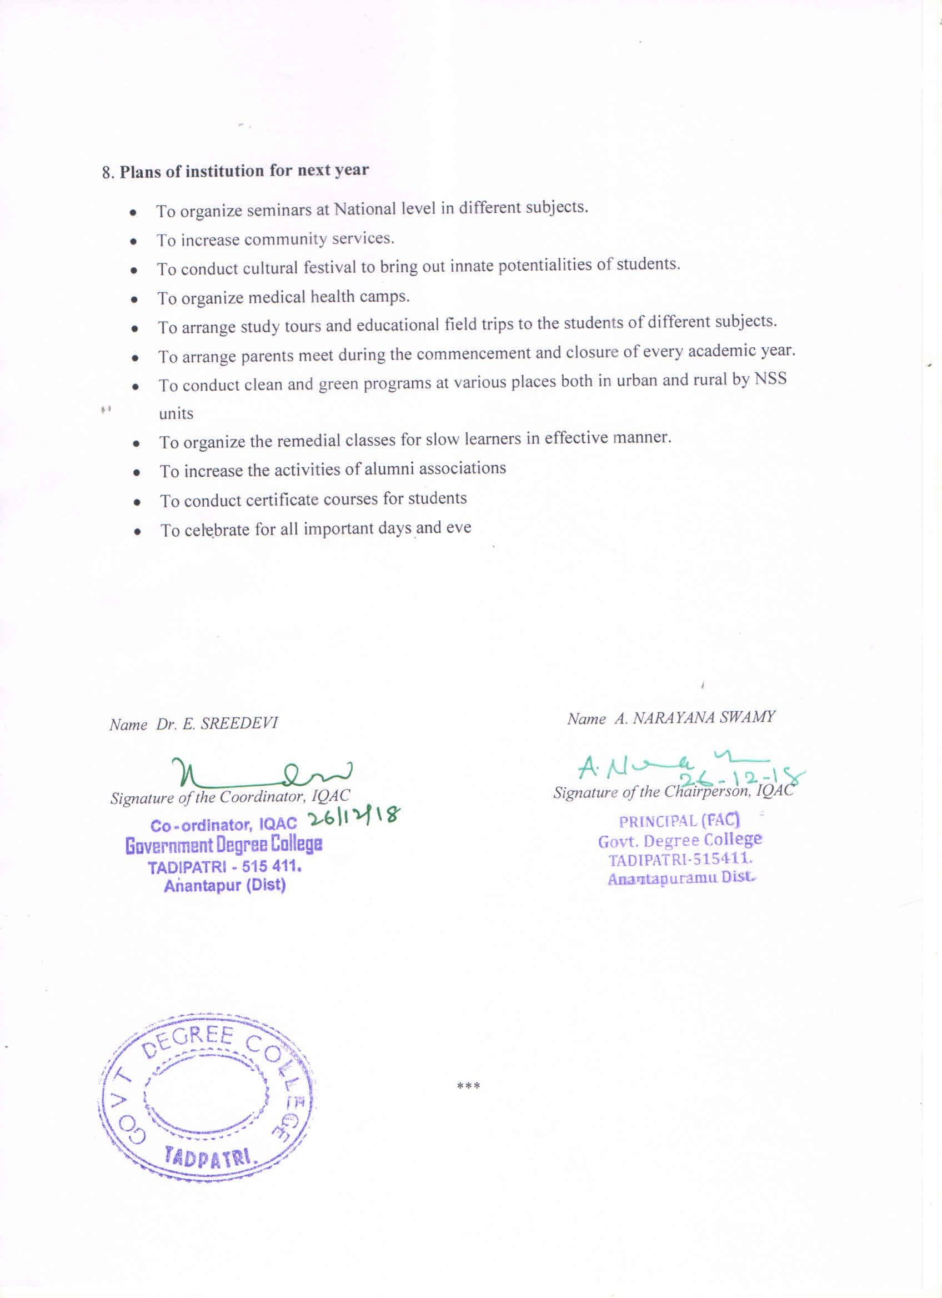

ANNEXURE –I
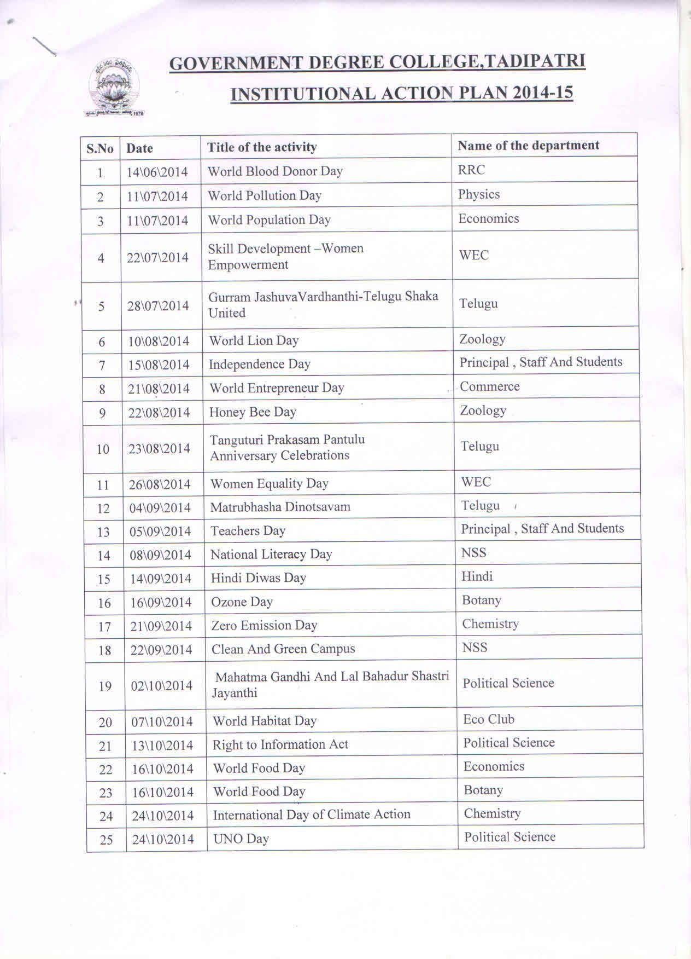
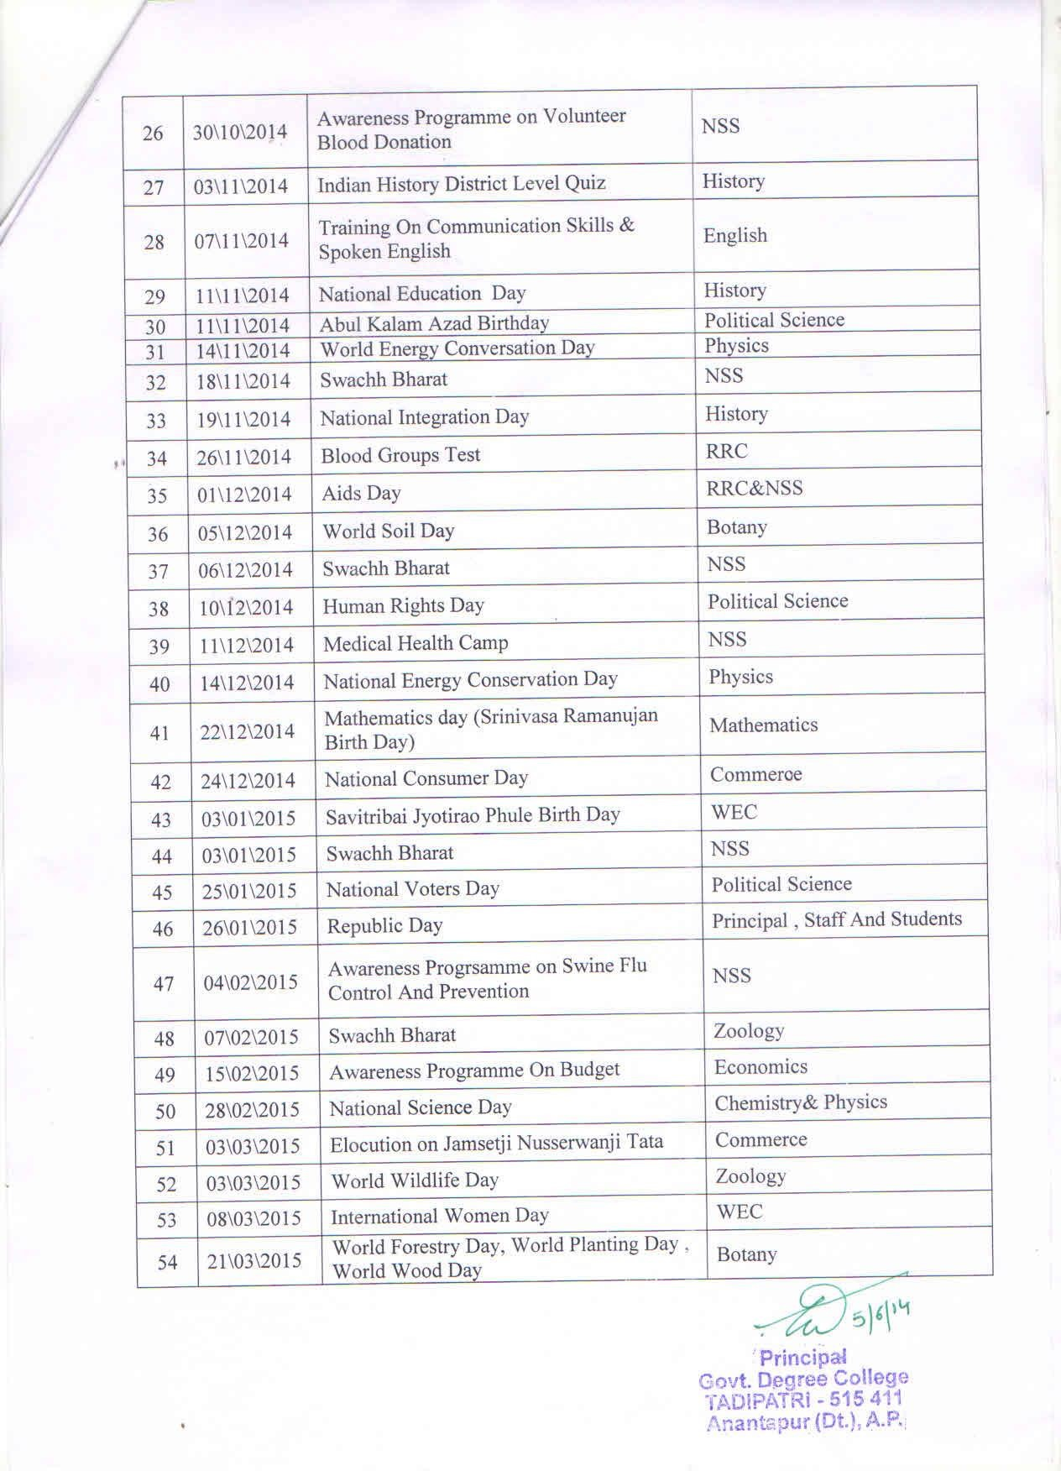
ANNEXURE-II
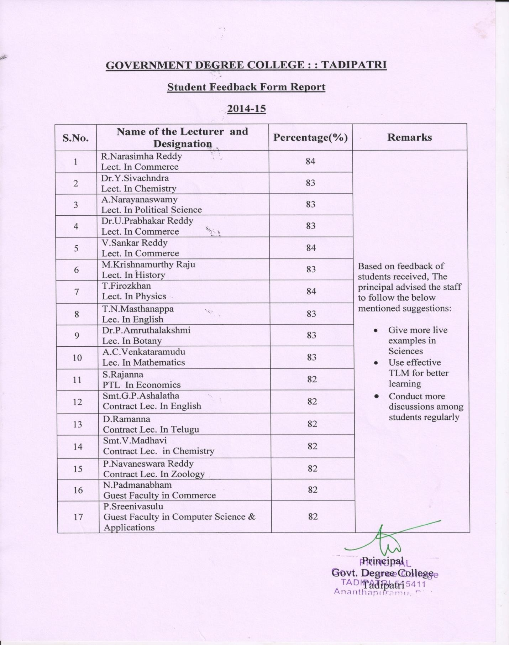

ANNEXURE- III
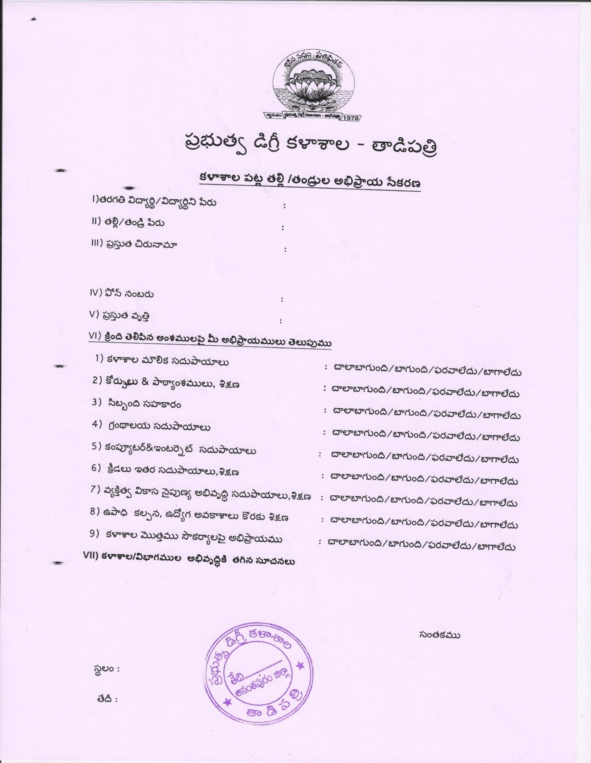
ANNEXURE-IV
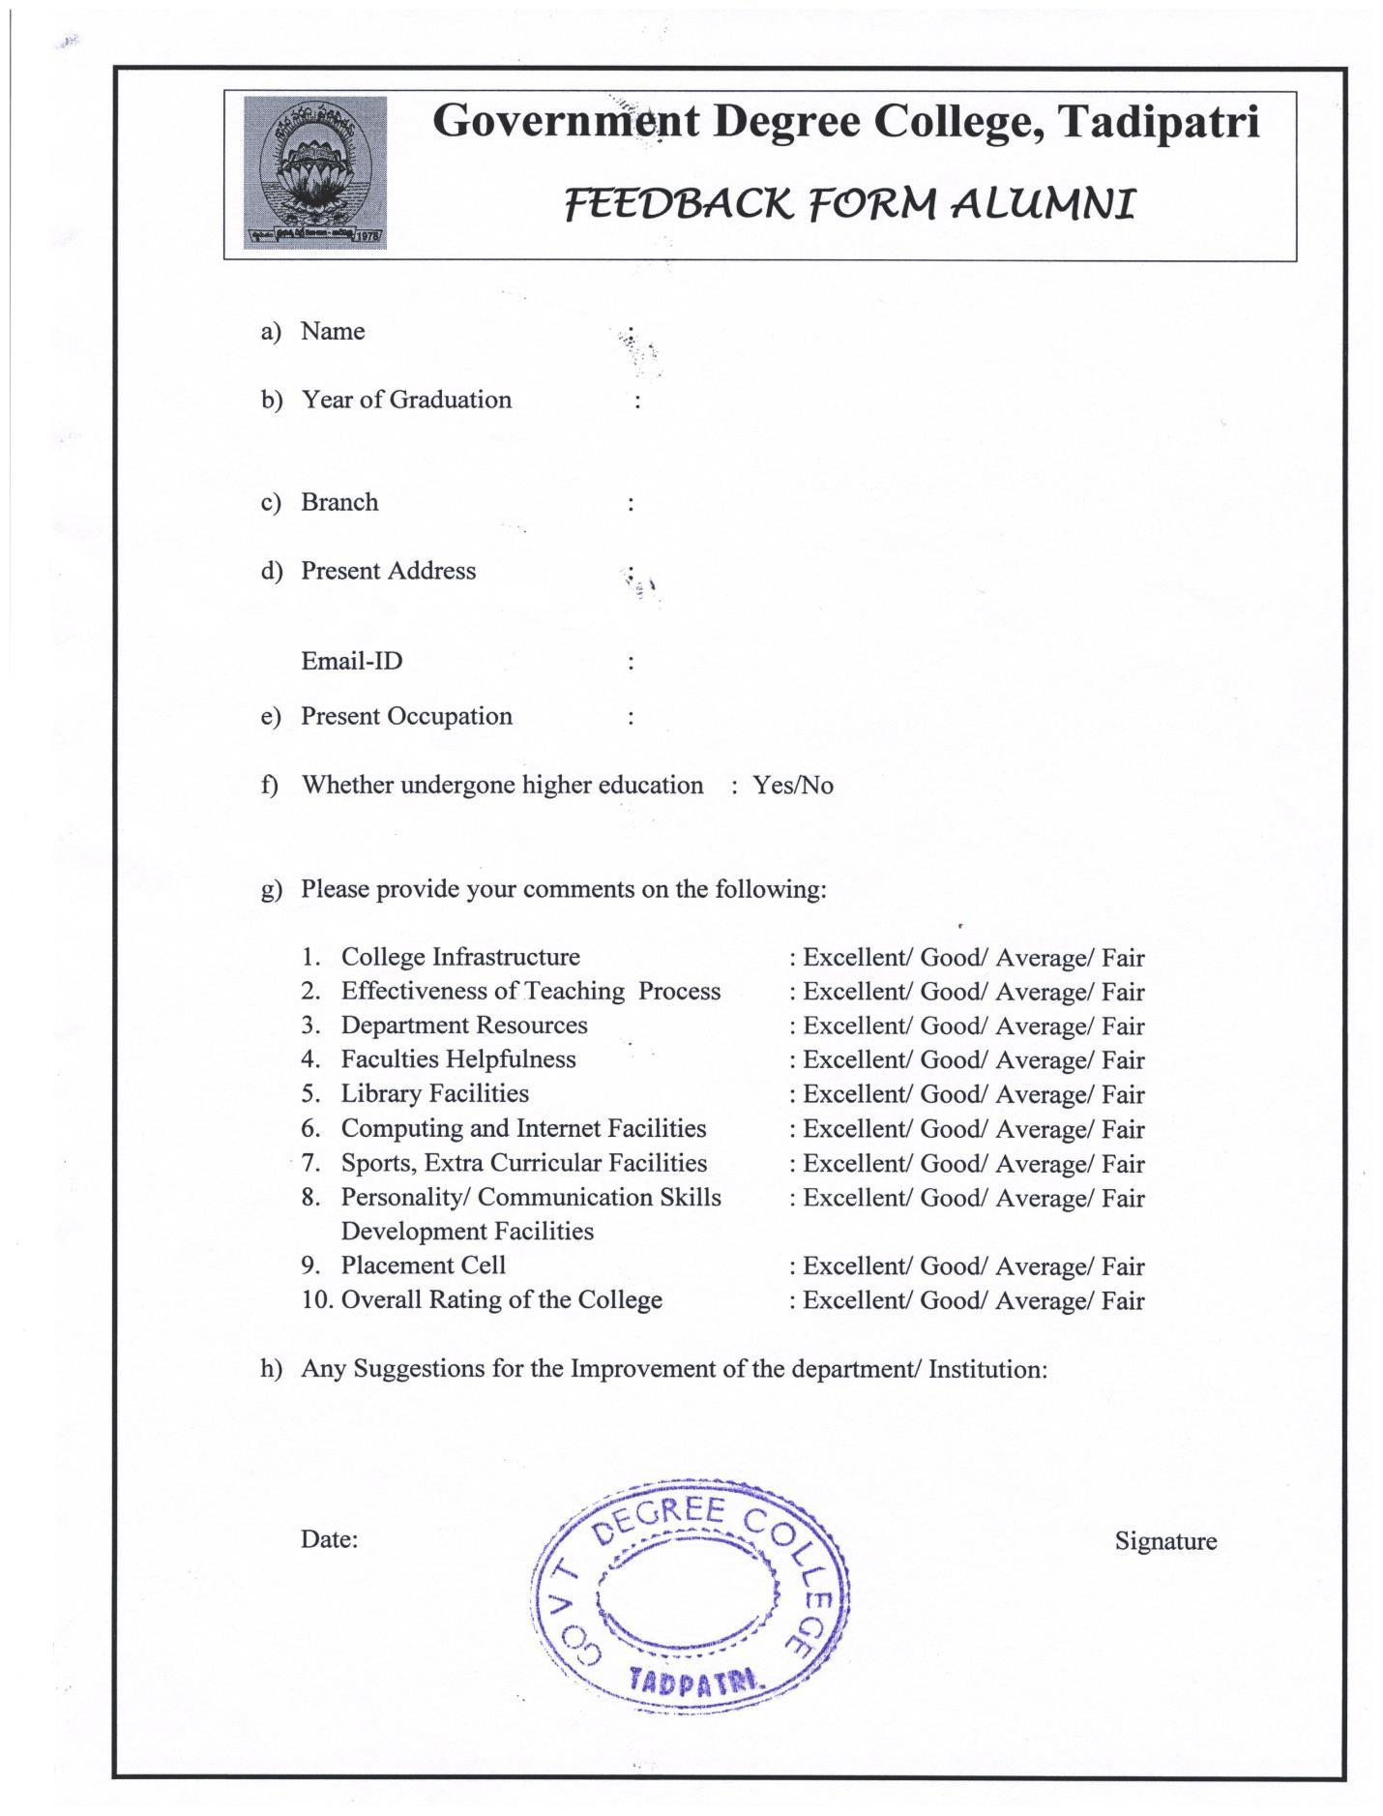

ANNEXURE-V Best Practice:1 1.Title of the Practice: Improving Teaching – Learning Process 2. Goal
To ensure the completion of syllabus according to the academic planner of each department To encourage teachers to adapt to technological advancements including ICT adoption in class room teaching
To improve pass percentage by the college at the university level examinations

3. The context
The syllabus coverage in some cases is being hurried and towards the end of the semester where information are being crammed at once. This sluggish coverage initially and hurried coverage later should be avoided giving enough time to student in comprehending the topics and assimilating the facts. The mismatch between the student learner and the teacher in the use and comfort of handling varieties of tools available for teaching – learning needs to bridged.

4. The practice
Academic planner along with the calendar of events is uploaded on the website for information to students.
The teaching – learning committee along with the heads of different departments monitor the pace of coverage of the syllabus.
Informal feedback is obtained from students regarding the content delivery by different teachers. The teaching – learning committee members and the class teachers hold frequent informal meetings and cull out the information needed.
Frequent assignments, tests and evaluation are conducted to improve performance in the semester – end examinations
Some class rooms are made ICT ready and many departments have the necessary tools for handling the class room teaching with the help of ICT.
JKC staff and programmers train the teachers in the use of Power Point Presentations, browsing the internet for useful resources, uploading content on the college website, use of google docs for information sharing, etc.

5. Evidence of Success
Some of the teachers have adopted modern pedagogic styles and ICT in their classes.
Some of the notes are uploaded on the college website.
Increased attendance in the classes and Improvement in results.
6. Problems encountered and Resources required.
Development of animation based power point presentations in teaching, particularly in science subjects, has been hindered due to the want of in – house technical expertise.
The demand for ICT resources is increasing and paucity of funds has been the biggest impediment which may dampen the spirit of technology adoption by teachers.

ANNEXURE-VI Best Practice-2 Title of the Activity: Need Based Community Service for schools
Goal: To develop teaching skills, teach while studying and competencies
Context: There is large number of vacancies existing in schools due to non filling up of posts through recruitment. Hence schools are facing lot of problems for completion of syllabus and fulfil academic curriculum. To provide support and overcome from this it has planned this community service.
Practice: The IQAC of college organizes need based community service every year by identifying and mobilising group of students interested in community development to meet needs of school children in Government High School, Tadipatri. Students of Govt. Degree College, Tadipatri help participated actively in completing a part of the syllabus as the school faces problem of inadequate teachers. Two weeks services are given by the UG students of the college. The management appreciates their contribution and award them with certificates.

Evidence of Success
All students participated actively and students of the school quickly responded

Problems encountered and Resources required.
Transportation and financial constrain
Lagging of syllabus for UG Students

